
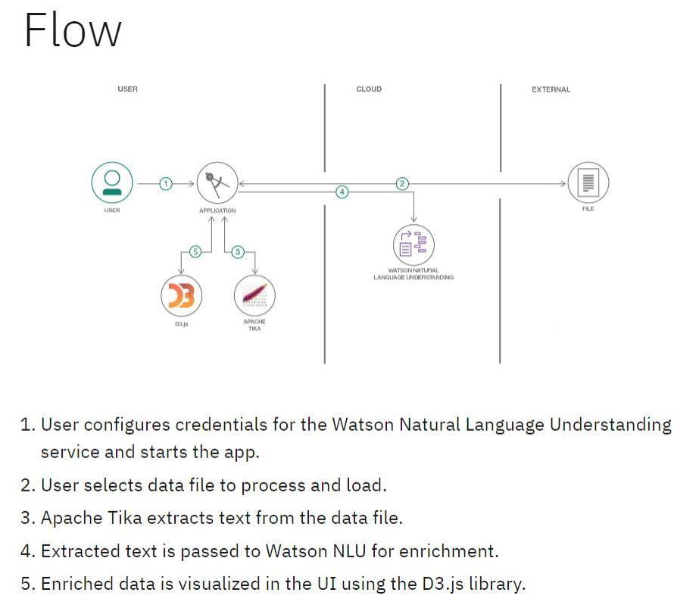
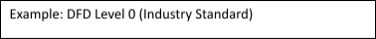
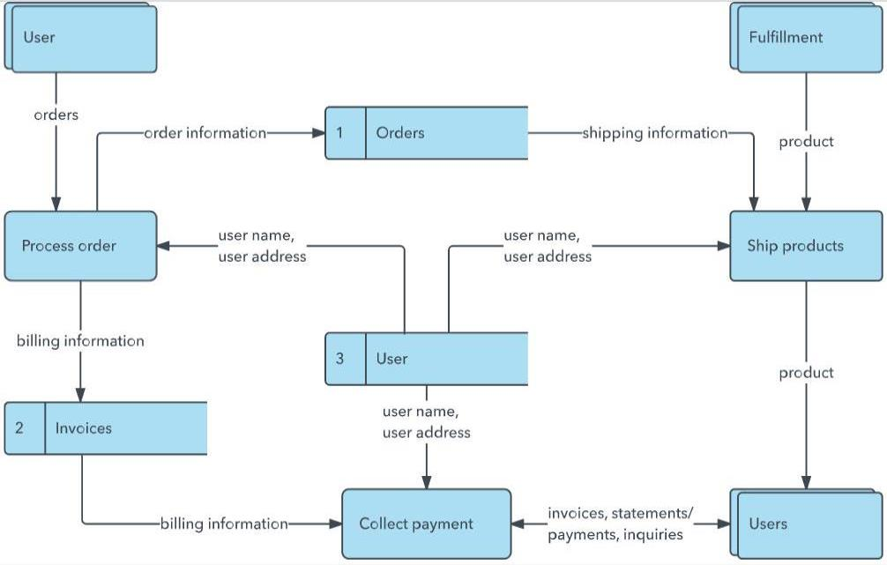
Example: (Simplified)
Date
Project Design Phase-II
Data Flow Diagram & User Stories
28 June 2025
Team ID
Project Name
4 Marks
Maximum Marks
Data Flow Diagrams:
A Data Flow Diagram (DFD) is a traditional visual representation of the information flows within a system. A neat and clear DFD can depict the right
amount of the system requirement graphically. It shows how data enters and leaves the system, what changes the information, and where data is
stored.
LTVIP2025TMID28557
Laptop Request Catalog Item

dashboard
Functional
User Type
Number
Requirement
(Epic)
Sprint-1
High
I can access my account /
As a user, I can register for the application by
USN-1
Registration
Customer
User Story
(Mobile user)
my password.
Sprint-1
High
I can receive confirmation
As a user, I will receive confirmation email
USN-2
email & click confirm
once I have registered for the application
Sprint-2
Low
entering my email, password, and confirming
User Stories
Use the below template to list all the user stories for the product.
Release
Priority
Acceptance criteria
User Story / Task
Customer (Web
user)
Customer Care
Executive
Administrator
As a user, I can register for the application
entering email & password
I can register & access the
USN-3
dashboard with Facebook
through Facebook
Login
Sprint-1
Medium
As a user, I can register for the application
USN-4
through Gmail
Sprint-1
High
Dashboard
Login
USN-5
As a user, I can log into the application by

Admin
Laptop Request USN-8
As an admin, I canCatrackn seeallall requestMedataium
Sprint-2
Manager
Laptop Request USN-7
As a manager, I canAbleapproveto approorve/reject
High request
Sprint-2
Employee
Laptop Request USN-6
As an employee,RI ecanquerequestst visible inHsystemigh
Sprint-2
User Type
Functional Requirement
User Sto(Epic)ry NumberUser Story / TaskAcceptance Criteria
Priority
Release
Additional User Stories: Laptop Request Catalog Item

